**Risk Analysis**

There is no guarantee on any project. When we are planning our project, risks are still uncertain because they haven’t happened yet. But eventually some of the risk which we are plan to be happen and that’s when we can deal with them. In the Context establishment phase the overall system is tested, then we have to decide the structure of the risk. Later the identification of risk has to done so that we can figure out the known risks. After identification of a risk there comes the phase of analyzing and understanding the risk and we should develop various scheme to overcome it. After analyzing the risk, the best thing, we can do is avoid it, so that it definitely won’t hurt our project. But if that may not be an option the we can mitigate the risk. If the risk is solvable then it goes to the mitigation phase where it gets solved. If the risk doesn’t mitigate then again it goes to the context establishment phase and follows the same subsequent phase. After the mitigation phase if the risk gets solved then it’ll gets accepted or the same procedure starts from context establishment.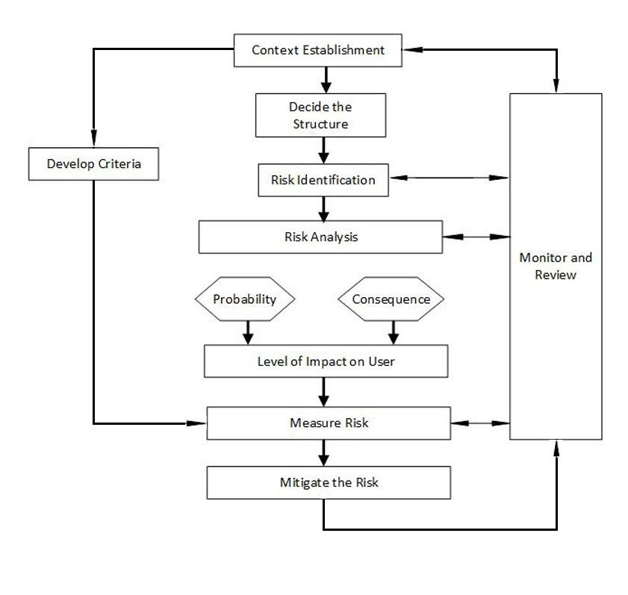

|  |  |  |  |  |  |  |
| --- | --- | --- | --- | --- | --- | --- |
| **Risk**  **No.** | **Name of the Risk** | **Risk Description** | **Risk Potential** | **Risk Probability** | **Impact on User** | **Mitigation**  **Strategies** |
| **Process and Management Risk** | | | | | | |
| R1 | Improper project schedule | Every project has a fixed deadline. If the time gets delayed it’ll generate more competitor in the market which will lead to huge loss. | Marginable | Medium | Low | The project workflow should be optimized. |
| R2 | Lack of Sufficient Resources | While development of the project maybe the resources are insufficient to finish the task in time. | Critical | Low | Low | We have to hire new staff, contractors who will support in development of the project. |
| R3 | Sudden change in Requirement | If the requirement of the user changes or the company plans to go another way to attract customer it’ll affect the project. | Critical | High | Low | Convince the customer that this platform can improve the business perfectly. |
| R4 | Change in Politics | Sometimes overlapping government function can have impact on business. | Catastrophic | Medium | Low | Keep familiar relationship between business and political authorities is a cooperative arrangement. |
| R5 | Negative feedback from customer | If the customers were not satisfied with the application then they’ll give negative feedback to the product which may leads to poor marketing. | Catastrophic | High | Low | Make spontaneous improvement in the application and respond to the customer quickly. |
| **Technical Risks** | | | | | | |
| R6 | Compatibility Issue | Due to rapid change in technology the application may not work on the user’s system. | Critical | Low | High | The user has to buy the compatible device. |
| R7 | Memory management | Because of high collection of graphical data and frequent updates there might be problem with memory management depending upon the size of the user’s hardware. | Marginable | Low | High | The user has to either increase the memory space by removing other data or have to buy a new device. |
| R8 | Application Crash | Sometimes due to some unknown reasons the application stops working or crashes. | Critical | High | High | Find where the trouble has been generated and ameliorate it as soon as possible. |
| R9 | Battery Backup Issue | Due to the usage of more graphical data, the battery may drain out quickly. So, it’s an obstacle in learning process of the child. | Marginable | Low | High | The user has to buy new device if the battery drains out very quickly and the user can also keep on the Battery Saver Mode. |
| **Users Experience Risk** | | | | | | |
| R10 | Bacterial Meningitis | The Food and Drug Administration received reports of bacterial meningitis in children who were less than six years of age with cochlear implants for treatment of hearing loss | Catastrophic | Low | Extreme | Health care providers should ensure that all children who receive cochlear implants are appropriately vaccinated and treated promptly for bacterial infection. |
| R11 | Children’s Understanding | A child might face difficulty in understanding how these application works | Marginable | High | Low | The parents should guide their children to become more friendly with the application |
| R12 | Neurocognitive risk in children having cochlear implant | In most domains of executive functioning, children with Cochlear Implant were at 2 to 5 times greater risk of clinically significant deficits compared with children with Normal Hearing. | Critical | Low | Extreme | Screening for risk of executive functioning deficits should be a routine part of the clinical evaluation of all children with deafness and CIs. |
| R13 | Obsession with the Games | It is a common sight today to see children glued to a digital device for hours. This is causing serious damage to children | Critical | High | High | The parents should limit their time for using of smartphones, tablets and encourage them to do other activities. |
| R14 | Magnet Displacement | The magnet of the cochlear implant gets displaced, then it’ll cause minor central balance disorder and neuromuscular weakness. | Catastrophic | Low | Extreme | They have to do an MRI scan and then replace the magnet with another one. |
| R15 | Limitation in Learning | After a child finishes all of the levels of the game, Then the application will be worthless to the child. | Marginable | High | Low | The developer should create levels or new game spontaneously so that a child can enjoy learning unendingly. |

**Risk Assessment Matrix**

|  |  |  |  |  |
| --- | --- | --- | --- | --- |
|  | **Negligible** | **Marginable** | **Critical** | **Catastrophic** |
| **Low** | Low | Low | Medium | High |
| **Medium** | Low | Medium | High | Extreme |
| **High** | Medium | High | High | Extreme |
| **Extreme** | High | High | Extreme | Extreme |



**Risk Matrix Grid**

